Name : Dev Adnani

ID : 202212012

Subject : Software Engineering

Assignment : 8

Q1 Class Diagram

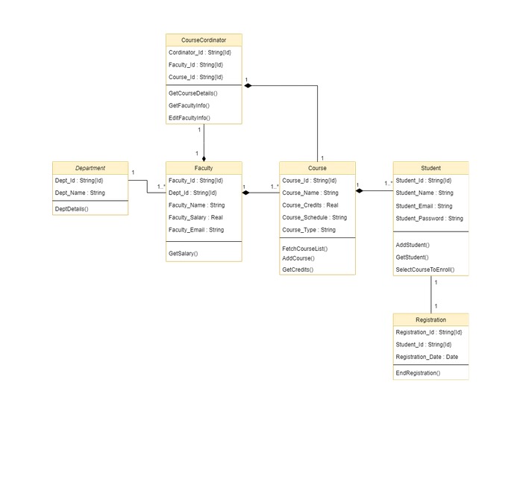

Q1 Sequence Diagram

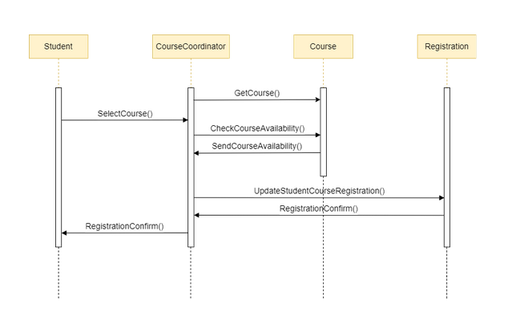

Q1 Usecase Diagram

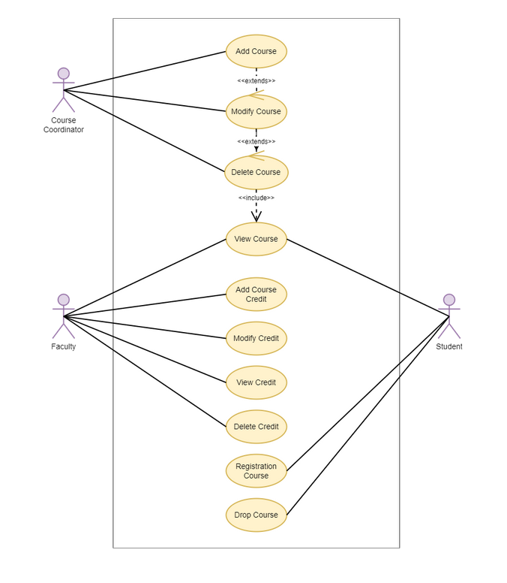

Q2: Use Case

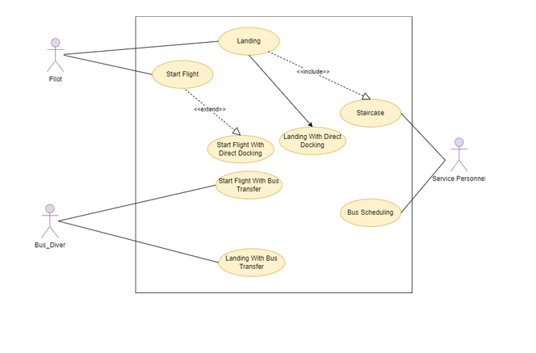

Q3 -> Code

Customer :

public class Customer{

private String name,address;

}

Order :

class Order{

private LocalDate date = LocalDate.now();

private String status;

void calcSubTotal();

void calcTax();

void calcTotal();

void calcTotalWeight();

}

Item :

class Item{

private int shippingWeight;

private String description;

void getPriceForQuantity();

void getTax();

void inStock();

}

Order Detail :

class OrderDetail{

private int quality;

private String taxStatus;

void calcSubTotal();

void calcWeight();

void calcTax();

}

Payment :

class Payment{

private float payment;

}

Cash :

class Cash extends Payment{

private float cashTendered;

}

Check :

class Check extends Payment{

private String name, bankID;

public void authorized();

}

Credit :

class Credit extends Payment{

private String name, type;

private LocalDate expDate = LocalDate.now();

public void authorized();

}